Virtual Horsepower Gauge – PHEV - FHEV – CGEA 1.3

Functional Description
The purpose of the Virtual Horsepower Gauge is to engage the driver, by providing the following information:
- The total power provided by IC engine and electric battery.
- The negative power (harvesting power’ or ‘Charging’) when it is in regen. (on applicable programs)

The Horsepower Gauge correlates the PwWhllvl_Pc_Dsply, BattPwWhl_Pc_Dsply signals, and the Operational Mode to generate a needle position.

The Horsepower Gauge shall provide a Virtual gauge with a rotating pointer to indicate the power demanded by the driver. The Horsepower Gauge pointer shall rotate clockwise to register increasing power and rotate counterclockwise to register decreasing power. The power Gauge shall be capable of indicating the power in ‘KiloWatt(kW)’.
Graphics are unique for China variant, thus we use China BEV/xHEV configuration.

Interfaces

Interface Context Diagram (I/O Block Diagram)

Power Gauge Context Diagram

Inputs

IR-REQ-344547/A-Internal
- Operational_Mode

MUX signals on the CAN Bus

SIG-REQ-344548/B-PwWhlLvl_Pc_Dsply Signal*

Signal Name | Size (bits) | Detail | Units | Res. | Offset | State Encoded | Min | Max
PwWhlLvl_Pc_Dsply | 10 | Driver Requested Vehicle Power | % | 0.2 | -102.2 |  | -102.2  (0x0) | 102.4 (0x3FF)
PwWhlLvl_Pc_Dsply provides total total amount of power provided for traction by IC engine (power only to wheel) and the electric motor (battery to wheels) along with the Regen power from braking.
* This is a signed signals.
Signal values from 0x0 through 0xA are to be treated as Min Cap (-100%)
Signal values of 0xB through 0x3F3 map to 0% through 100%
Signal values from 0x3F4 through 0x3FF are to be treated as Max Cap (100%)

SIG-REQ-344549/B-BattPwWhl_Pc_Dsply Signal

Signal Name | Size (bits) | Detail | Units | Res. | Offset | State Encoded | Min | Max
BattPwWhl_Pc_Dsply |  | Electrical power to wheels | % | 0.1 | 0 |  | 0  (0x0) | 102.3 (0x3FF)
BattPwWhl_Pc_Dsply presents the power based on the electrical power to wheels percentage output transmitted by the
HPCM.
- BattPwWhl_Pc_Dsply, Battery power gauge display level in percent (%).

SIG-REQ-355009/B-HybMdeStat_D_Dsply Signal

Not Applicable.

SIG-REQ-355010/B-EngActv_B_Dsply Signal

Signal Name | Size (bits) | Detail | Units | Res. | Offset | State Encoded | Min | Max
EngActv_B_Dsply | 1 |  | SED | 1 | 0 |  | 0 (0x0) | 1 (0x1)
 |  | Off |  |  |  | 0x0
 |  | On |  |  |  | 0x1

IR-REQ-344550/A-Outputs
Power Gauge Indication -- pointer value in kW

Function/Performance

F-REQ-344551/A- Operational Modes

Mode | Differentiating Vehicle Conditions
Sleep Mode | Power Gauge pointer at ‘Rest Position’
Limited Mode | Power Gauge pointer at ‘Rest Position’
Normal Mode | Power Gauge pointer at “Power Gauge Indication”
Crank Mode | Power Gauge pointer at “Power Gauge Indication”

Operational Modes Voltage Levels

Refer to the Cluster Features table located in the Operational Modes and Voltage Range Strategies Section of this SPSS.

Human-Machine Interface

Visual

Indicator Graphics / Display Format
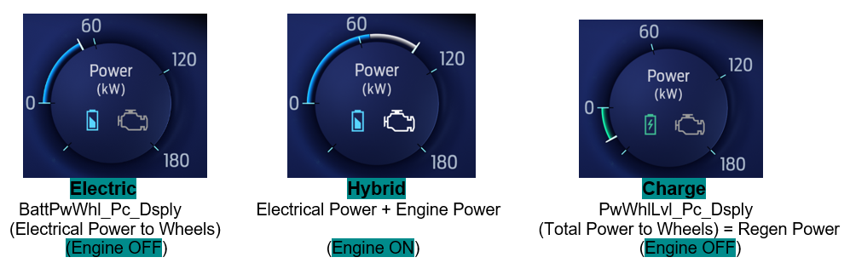

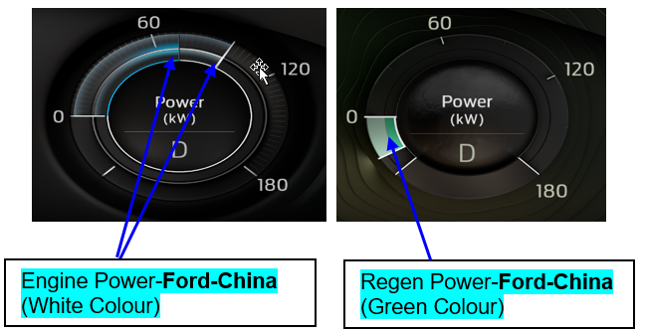

Above are example graphics. Actual graphics are to be provided by Ford HMI or Studio and approved by the DI Application for each program. Scale number also in example graphics are just for reference and unique to program so you should just refer to graphics when addressing scale.

HMI-REQ-344553/B-Gauge Color specification in various modes

The IPC shall display the power supplied by the electric motor in blue, the power supplied by the engine in white, and the power from Regen in green on the digital horsepower gauge. The color code is used in order to inform the customer the source of the power.

HMI-REQ-344552/B-China ICON

When configured for China Power Gauge shall not show any symbol from Battery or Engine symbol.

Gauge Scale

The idea is simply to scale the signal from 0 to max scale number (max sweep) on the positive side (no scale numbers provided – just depends on graphics provided and from 0 to the negative max sweep on the negative side (no scale numbers provided – just depends on graphics provided). It’s like piecewise linear.

F-REQ-344554/A-Gauge Units

The units for all programs right now will be kilowatts (kW) as shown in latest graphics.

Gauge Power source and interface with HPCM

Note: PwWhllvl_Pc_Dsply signal provided values in %. For % to kW mapping please check HMI graphics files (Note:
100% = Full Scale). Also HMI display range and scaling for regen green level indication provided in HMI graphics files.

The HPCM shall calculate and transmit the total amount of power provided for traction by IC engine (power only to wheel) and the electric motor (battery to wheels) along with the Regen power from braking. The output shall be in the form of percentage which shall be transmitted to the IPC.

The IPC shall filter and display the total electric power to wheels supplied by the traction motor. The IPC shall display the power based on the electrical power to wheels percentage output BattPwWhl_Pc_Dsply transmitted by the HPCM.

F-REQ-344555/A- Gauge Filtering

This is a fast changing gauge, so HMI should look smooth through filtering. Also additional filtering shall not cause the response of the gauge to be delayed more than is deemed acceptable

Indicator Color Coordinates

As per studio approved design.

Indicator Characteristics
As per studio approved design.

Audio
None.

Switch Control Logic

None

System Accuracy

Filtering
Shall indicate the data contained in PwWhllvl_Pc_Dsply Signal as per the same filtering applied on the Tachometer gauge.

F-REQ-344543/A-Smooth Pointer Movement
The Virtual Horsepower gauge must track all dynamic power requests with a smooth pointer movement with no greater than 300 millisecond lag and an overshoot/undershoot not to exceed 2% of full scale.

F-REQ-344544/A-Gauge traverse while transitioning to Sleep or Limited mode
The Power gauge pointer shall traverse to at least 90% of the travel to rest position within 1000mS and complete travel to rest position within an additional 300mS when transitioing to "Sleep Mode" or "Limited Mode.
Note : Use Tachometer gauge stepper filter parameters.

Operation: Performance and Functional

Subsystem Algorithm Flowchart / State Diagram

F-REQ-344537/A-Flowchart for CAN Diagnostic Configuration Routine

F-REQ-344538/C-Horsepower Gauge Process with Regen
Horsepower Gauge Process with Regen
(To be implemented on clusters that have a Regen portion of the gauge)

F-REQ-344540/C-Gauge Indication for Horsepower Gauge with Regen

Operational_Mode | PwWhllvl_Pc_Dsply Signal | Power Gauge  Pointer Position (kW) | Power Gauge Indication
Normal | 0x0 – 0xA | Min* | Regen Cap
Normal | 0xB – 0x1FE | (Min-1) to -1 | Linear Regen
Normal | 0x1FF | 0 | 0
Normal | 0x200 – 0x3F2 | 1 to (Max-1) | Linear Power
Normal | 0x3F3 – 0x3FF | Max* | Power Cap
Normal | Declared Missing | 0 | 0
All Other Cases |  | 0 | Off

F-REQ-344541/C-Horsepower Gauge Process without Regen
Horsepower Gauge Process without Regen
(To be implemented on clusters that do not have a Regen portion of the gauge)

F-REQ-344542/C-Gauge Indication for Horsepower Gauge without Regen

Operational_Mode | PwWhlLvl_PC_Dsply  Signal | Power Gauge  Pointer Position (kW) | Power Gauge Indication
Normal or Crank | 0x0 - 0x1FF | 0 | 0
Normal or Crank | 0x200 – 0x3F2 | 1 to (Max-1) | Linear Power
Normal or Crank | 0x3F3 – 0x3FF | Max | Power Cap
Normal or Crank | Declared Missing | 0 | 0
All Other Cases |  | 0 | Off

F-REQ-354995/B-Numeric Display Battery Drive Power Calculation
Not Applicable.

F-REQ-354996/B-Numeric Display Engine Drive Power Calculation
Not Applicable.

F-REQ-354997/B-Numeric Display Regenerative Braking/Charge Power Calculation
Not Applicable.

F-REQ-354998/B-Power Gauge States Determination

F-REQ-355000/B-Battery and Engine Power Display
The cluster shall transition to the Hybrid Display when PwWhlLvl_Pc_Dsply greater than or equal to 0%. In the Hybrid Power Gauge Display, the Battery symbol is Blue and engine symbol status shall follow Engine status.

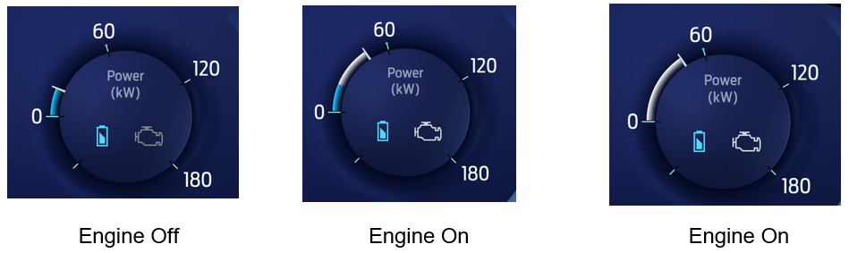

F-REQ-354999/B-Regenerative Power Display
The cluster shall transition to the Regenerative Power Display graphic when PwWhlLvl_Pc_Dsply is less than -1.5% for a 300 ms window. In the Regen Power Display, Battery symbol is Green and Engine symbol status should follow Engine Status signal.

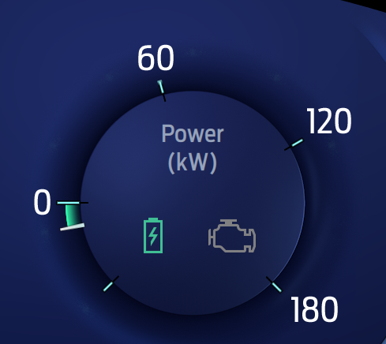


Regen with Engine OFF Regen with Engine ON

F-REQ-355007/B-Power Gauge Engine Status
The cluster shall use the engine status signal EngActv_B_Dsply to determine Engine symbol status.

Signal Name | Signal Value | Signal State | Engine Symbol
EngActv_B_Dsply | 0x0 | Off | Gray
 | 0x1 | On | White

Operation Description (supports algorithm flowchart /state diagram)

F-REQ-344531/B-Sampling Rate
The Horsepower Gauge shall sample the PwWhlLvl_PC_Dsply signal periodically at least once every 100 mS when in “Normal" or "Crank" Mode. Supplier must insure update rate fast enough to insure all performance requirements are met.

F-REQ-344532/A-Pointer Waver
The Horsepower Gauge shall not exhibit pointer waver exceeding 0.1% of total pointer travel range with a steady commanded input.

F-REQ-344533/A-Needle Waver
The Horsepower Gauge shall not exhibit needle waver exceeding 1/3 of an angular degree with a steady commanded input.

F-REQ-344534/B-Rest Position Condition
If PwWhlLvl_PC_Dsply = 0, the pointer position will be at the rest position (with needle pointer position indicated as per the studio approved design for the cluster)

F-REQ-344535/B-CAN Inavlid value
If PwWhlLvl_PC_Dsply > 100%, the gauge pointer shall remain at the 100% position, the pointer shall not go above 100% at any point in time.

F-REQ-344536/B-Missing Signals
In case of missing signal for PwWhlLvl_PC_Dsply, pointer position shall be at the rest position.
In case of missing signal for BattPwWhl_Pc_Dsply, we should only display the needle with the total power. No color shall be used on the gauge and no values shall be shown in the gauge.

FS-REQ-344520/A-Function Safety Classification (EMC)

B

NVM-REQ-344513/D-Memory Storage

Parameter Name | Description | Value at  Battery Connect | Value at  Module Wake-up
Operational_Mode | 4 state indicator for cluster operational mode | Limited | Limited, Normal or Crank
PwWhlLvl_Pc_Dsply | CAN signal sent from the HPCM | 0x0 | 0x0
BattPwWhl_Pc_Dsply | CAN signal sent from the HPCM | 0x0 | 0x0
Power Gauge Indication | Used to control the Power gauge pointer position. | 0 | 0
PT_Hyb_Cfg2 | Configuration bit for HEV Configuration.  PT Hybrid2(PT_Hyb_Cfg2)  0x0 = Non-Hybrid  0x1 = BEV  0x2 = FHEV  0x3 = PHEV  0x4 = MHEV | Do Not Init | Do Not Init
Welcome_Goodbye_Cfg | Welcome_Goodbye_Cfg | Do Not Init | Do Not Init
China BEV/xHEV Cfg | China BEV/xHEV Function | Do Not Init | Do Not Init

Prove Out

None

Reconfigurable Telltale

None.

Message Center Msg

None

SR-REQ-344501/A-Error Handling
The Power gauge shall be “0” (Rest Position) when determining an error condition.

Missing Message Strategy

The signals will be declared missing as per the Diagnostics section of this SPSS.

DTCs states and history will be determined as per the Diagnostics section of this SPSS.

Invalid Message Strategy

None

Diagnostics

Self Test

None

Engineering Test Mode

Reference section “Dealer / Engineering Test Mode (ETM)”

Part II Performance

DTC-REQ-344484/A-Supported Diagnostic Trouble Codes (DTCs)

DTC | Description
C29300 | Lost Communication with Hybrid/EV Powertrain Control Module

DCR-REQ-344485/A-DID DExx

Block  Num | Block Description | Byte(s) | Bits | State: Description | "0" | "1" | Default | Comments/  Information
$09 | Option Content (B&A) |  | 3 | PT Hybrid2(PT_Hyb_Cfg2)  0x0 = Non-Hybrid  0x1 = BEV  0x2 = FHEV  0x3 = PHEV  0x4 = MHEV |  |  | 0x0 | Default from cluster plant to be 0x0 if cluster can be used on a Non-Hybrid.
$09 | Option Content (B&A) | * | * | China BEV/xHEV Function | Not China | China | Not China | For China (Peoples Republic of China) must be set to China for compliance to China reg GB/T 4094.2-2005. Taiwan MUST be set to Not China.

Reference Specification
- Instr. & Gauges (indic. Grad) IS-0015
- Gauge Durab. IS-0033

Revision History
SPSS Module Revision History

Revision Level | Name | Change Description | Date
1.0 | H. Sharma | Initial Release | 10/20/2017
1.1 | H. Sharma | Section 1.2.1(Interface Context Diagram updated to add China BEV/xHEV configuration and updated PT_Hybrid_Cfg to PT_Hybrid_Cfg2.  Section 1.3.3.1.1 is updated to include China example for regulatory change. Battery symbol is removed from China graphics.  Figure 2(Flowchart for CAN Diagnostic Configuration Routine) is updated to add China configuration.  Section 1.5.3 is updated to remove Invalid data DTC #59400 logging  Chnages are marked in Turquoise color. | 06/18/2018
1.2 | H. Sharma | Minor updates perfomed based on supplier Q&A. All changes are marked in Green color.  - EffWhlLvl2_PC_Dsply definiation updated to match CAN DBC.  - Figure 3 & 4 updated to correct CAN signal names.  - ‘0’ Position and ‘Rest’ position were used at different places. Both are same thing, corresponding updates are made.  - Table 1.2 & 1.3 updated for CAN signal range mapping with gauge postion. | 10/26/2018
1.3 | H. Sharma | Initial VSEM release | 02/12/2019
1.4 | H. Sharma | This request came from EPE and approved offline by Randall Chinoski on 04/15/2019. All updates for this release are marked in Yellow color. In this update, existing CAN signal replaced with new CAN signal as mentioned below :  - Use PwWhllvl_Pc_Dsply instead of EffWhlLvl2_Pc_Dsply  In addition, the power gauge is applicable to all markets and applicable to FHEV and PHEV.  - Section 1.1, Functional Description updated for CAN signals  - Section 1.2.1, Context Diagram updated for CAN signals.  - Section 1.2.2.2.1 & 1.2.2.2.2 are updated for CAN signal definition.  - Section 1.3.3.1.1 is updated for CAN Signals  - Section 1.3.3.1.1.5 is updated for CAN signal  - Section 1.3.4.1 is updated for CAN signal  - Section 1.3.5.1.2 F-REQ-344538 flow chart is updated for CAN signals  - Section 1.3.5.1.3 F-REQ-344540 updated for CAN signals.  - Section 1.3.5.1.4 F-REQ-344541 flow chart is updated for CAN signals  - Section 1.3.5.1.3 F-REQ-344542 updated for CAN signals.  - Section 1.3.5.2, Operational Description updated for CAN signals  - Section 1.3.5.4 NVM-REQ-344513 is updated for CAN signals. | 04/16/2019
1.5 | H. Sharma | This update is to fix Power gauge behavior where it flicker between Electric and Hybrid mode display. This update was approved offline by Scott Watkins on 06/18 for STSS update.  All the updates are marked in Pink color.  - Section 1.2.1, context diagram updated to add two new CAN signals HybMdeStat_D_Dsply and EngActv_B_Dsply  - Section 1.2.2.2.3 added for new CAN signal HybMdeStat_D_Dsply  - Section 1.2.2.2.4 added for new CAN signal EngActv_B_Dsply  - New Sections 1.3.5.1.6 to 1.3.5.1.9 added to define gauge display behavior in electric and hybrid modes.  - Section 1.3.5.4, updated to add Battery_Power_Display, Engine_Power_Display & Charge_Power_Display internal display variables. | 06/23/2019
1.6 | H. Sharma | This request came from EPE team and approved offline by Scott Watkins on 07/18. In this update, the power gauge will not stop from updating when the BattPwWhl_Pc_Dsply is 0. DICC tracking number # 412. Changes are marked in Teal color.  - Section 1.2.1, updated to remove HybMdeStat_D_Dsply  - Section 1.2.2.2.3 is updated to remove HybMdeStat_D_Dsply signal  - Section 1.3.3.1.1, updated as per latest graphics.  - Section 1.3.3.1.1.2 HMI-REQ-344552, update to clarify no symbols will be shown for China.  - Section 1.3.5.1.2, F-REQ-344538 is updated not to stop gauge update when BattPwWhl_Pc_Dsply = 0 in flow chart.  - Section 1.3.5.1.3, F-REQ-344540 updated to remove Min-Max range, as there is no number display now.  - Section 1.3.5.1.4, F-REQ-344541 is updated not to stop gauge update when BattPwWhl_Pc_Dsply = 0 in flow chart.  - Section 1.3.5.1.5, F-REQ-344542 updated to remove Min-Max range, as there is no number display now.  - In section 1.3.5.1, F-REQ-354995, 96 & 97 are no more applicable.  - Section 1.3.5.1.9 F-REQ-354998, updated as per new graphics. | 09/03/2019

